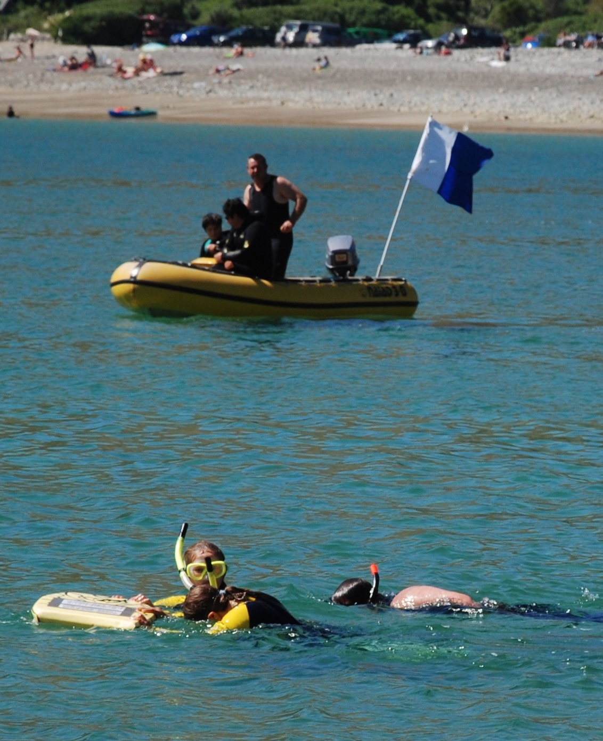
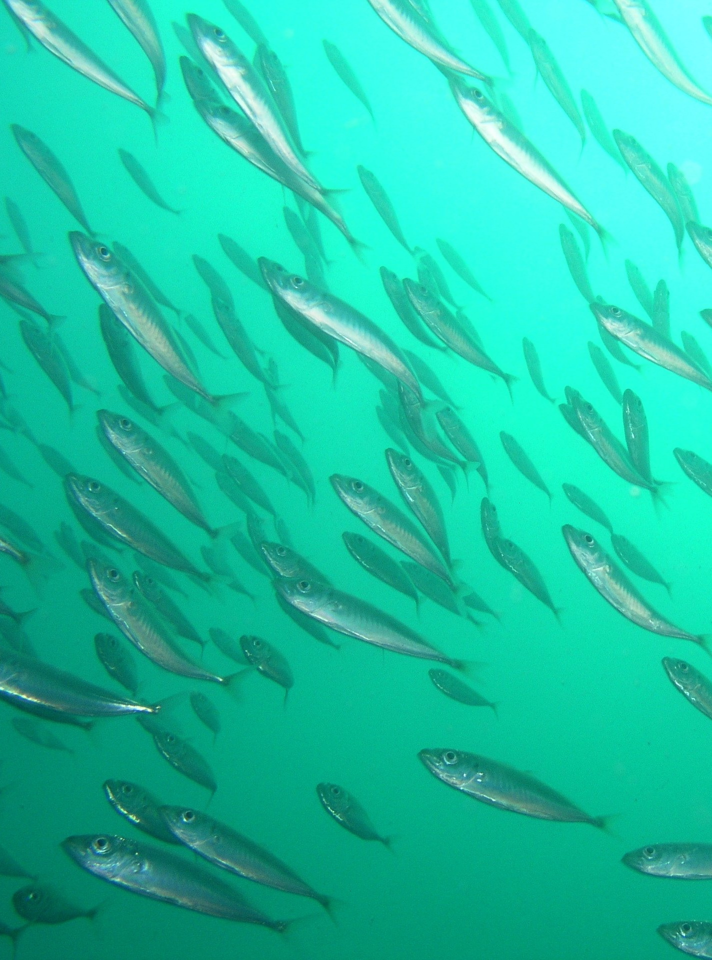
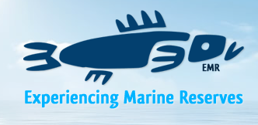

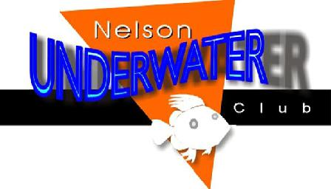
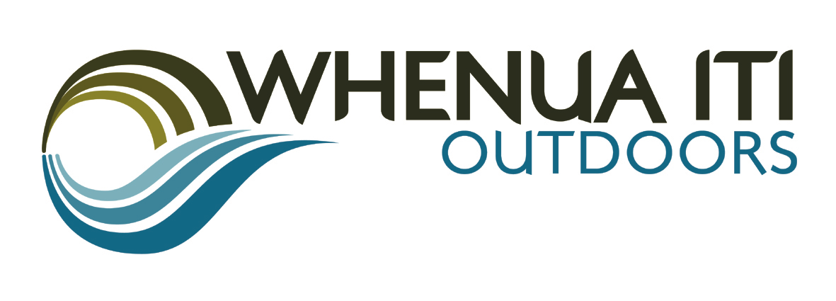
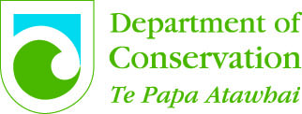
LOOK BENEATH THE SURFACE!
Papatai ō roto – Papatai ō raro

Community Guided Snorkel Day

Cable Bay
Saturday 21st January
FREE event
Supported by Port Nelson
Gold coin donation welcomed
Arrive and register
any time between 9am and 12pm

Snorkel guides, body-boards,

wetsuits, fins, snorkels and masks provided FREE or bring your own gear

For 5 years and over

under 15 years must be accompanied by an adult

Sea conditions permitting
Check out ‘EMR Nelson on Facebook for weather updates.

Find out more information at
www.itson.co.nz

