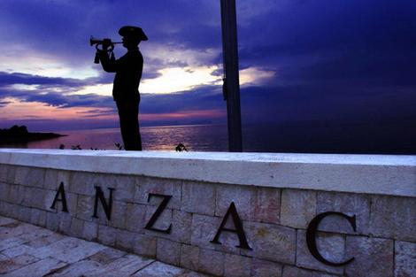

Tickets $25, Under 18’s $5: i-Site - Trafalgar St, Summit Real Estate - Stoke, Richmond Mall reception area or door sales on the day (cash only).

Tuesday, April 25th 2017 at 2.00pm

Annesbrook Auditorium,

40, Saxton Road, Stoke

**Presents**

**“Those that fell”**

**An Anzac tribute**

**featuring Logan Ford on cornet**

NELSON MALE VOICE CHOIR

Conductor, Andrea Hamilton, with Pauline Boyd and Susan Stokes