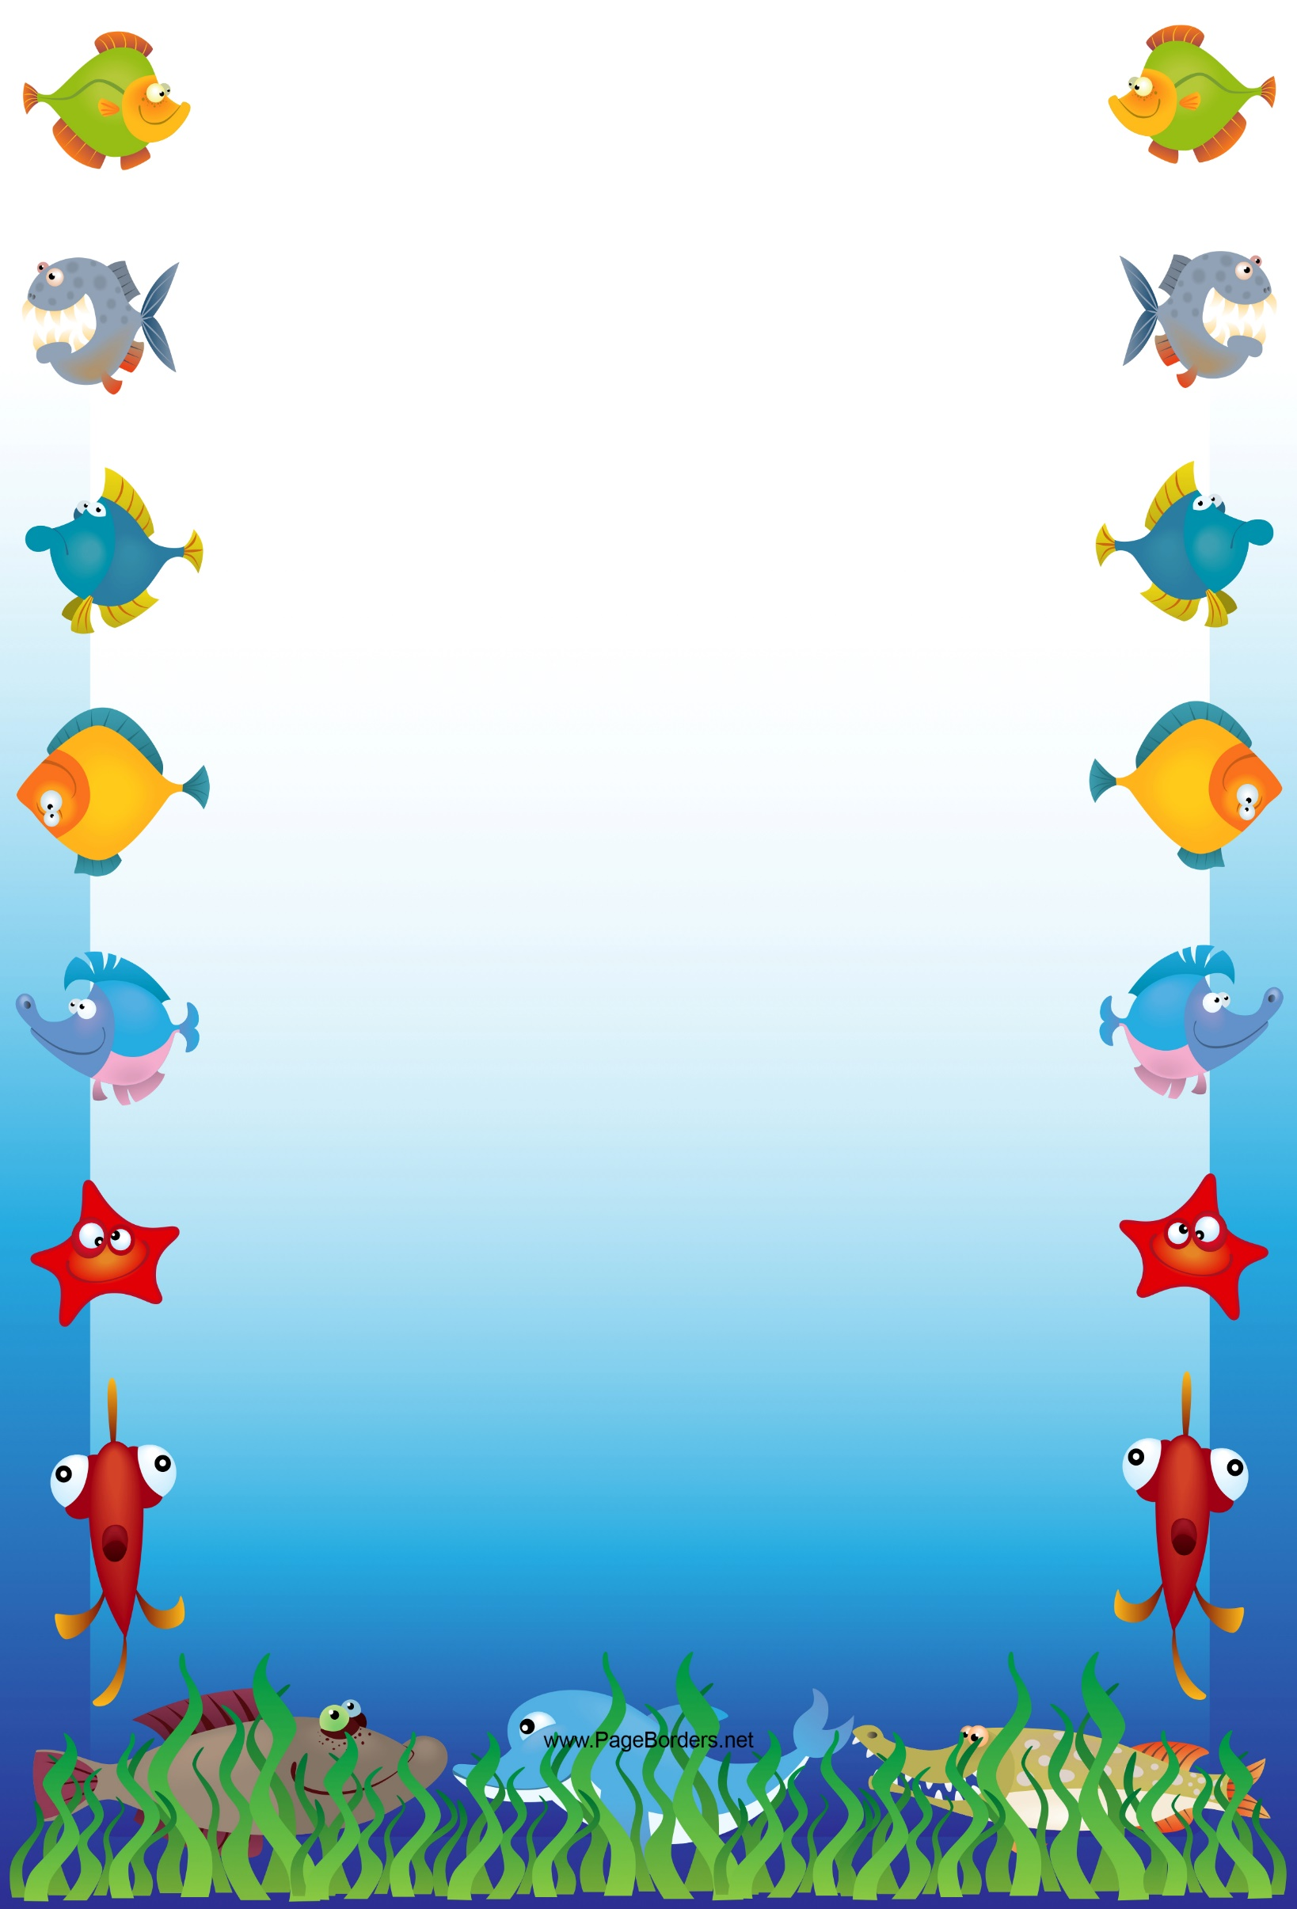
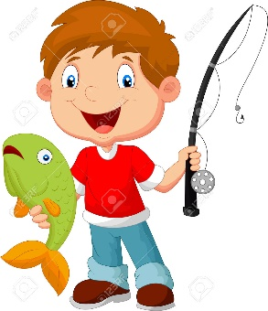

MAPUA BOAT CLUB
KIDS FISHING COMPETITION

Where - Mapua Wharf
When - Sunday 11th Nov 2018
Time – Lines in 1pm - out 2.30pm
Registration from 12.45pm

3 Categories:
- Under six years
- 6 - 9 years
- 10 – 12 years

Spot prizes - sausage sizzle
Prize presentation

CONDITIONS OF ENTRY:
Only fish caught on lines win prizes
Maximum 3 hooks per line
Children to be accompanied by an adult at all times

Please direct enquiries to:
CLARE KININMONTH Email mapuabcsecretary@gmail.com
or phone/txt 0221771186

