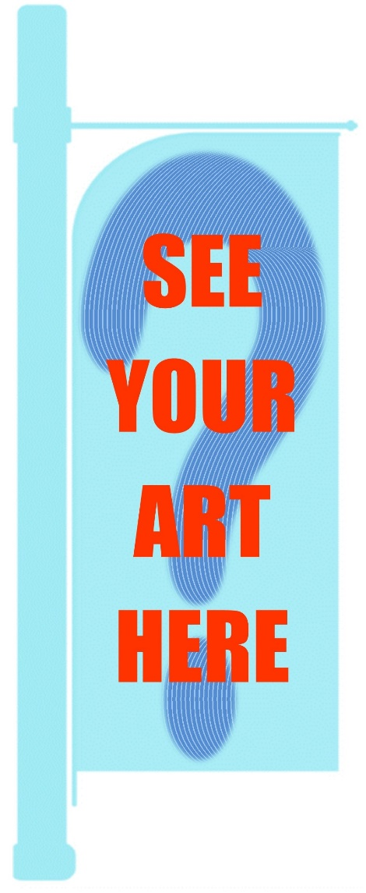
Art Flags for Nelson – Call for artists of all ages and abilities..
On behalf of Nelson City Council, Arts Council Nelson is thrilled to invite artists and designers from the Nelson region to submit design proposals for this exciting public art project.
The aim is to brighten up the city streets by creating 80 uniquely designed flags for display between major events, which will add diversity, colour and showcase local art in our smart little city.
We are seeking a diverse range of designs from artists residing in the Nelson region which are colourful, interesting, positive and fun. With this in mind, we welcome images from all ages, walks of life and ability in order to create these flags. Each selected artist will receive $300 for allowing Nelson City Council to use their image for this purpose.
Please note that there are specific size requirements, for full details refer to the terms and conditions of entry: available at http://www.acn.org.nz/art-flags-project.html
Last day for receiving entries is 23rd September 2019
Selected entrants advised by 26th September 2019
Flags will fly in November 2019!

ARTS FLAGS FOR NELSON - Terms and Conditions
Entry is open to all residents of the Nelson Region regardless of age and ability.
Any medium or creative process which is suitable for large scale digital reproduction may be used.
A maximum of two designs per person may be submitted. Work must be the artist’s own design and execution and not impinge on others intellectual property or copyright.
Entry is strictly by hard copy print reproduction of the design only. Please do not submit original artwork, full colour reproductions of designs are required in either A4 or A3 size portrait formats. A quality reproduction of the image is recommended as this will be used for the selection process.
Designs submissions must be in portrait format and strictly adhere to the dimensions specified: 256mm (h) x 140mm (w) on A4 size, or 350mm (h) x 190mm (w) on A3 size. Templates for these may be downloaded from http://www.acn.org.nz/art-flags-project.html for your convenience. Please be aware that the top left of the format may require a curved crop, and a footer will be superimposed by the organisers upon each design bearing the Nelson City Council logo. Please take these factors into consideration when creating your design, but do not include any logo in your design. Organisers reserve full editorial control of the placement of the logo footer and the top curved crop as required.
Each entry must be accompanied with a completed entry form, it is important that the entrants name is clearly written on the reverse of hard copy design images submitted.
Entries by artists under 18 years of age require consent from a parent / caregiver. Please complete the relevant section of the entry form if appropriate.
Whilst original artwork is not required for the selection process, selected entrants must be able to provide a high-resolution digital image from their original design. Specifications of these will accompany advice for the selected artists.
Should an entrant require their submitted copy to be returned to them a stamped addressed envelope must be attached to their submission. Alternatively, these may be collected from the ACN Office by arrangement before 31st October 2019.
The selection criteria
The Nelson Arts Panel will select 80 designs for the project with content that is colourful, interesting, positive and fun. Designs they consider confrontational, provocative, seasonal or commercial in nature will not be selected. Their decision will be final, and discussion will not be entered.
The selected entrants will be contacted personally, and a list of artists selected will be published on the Arts Council Nelson website by 27th September 2019.
Design Usage
Selected entrants shall receive a usage fee of $300 per chosen image. Nelson City Council shall retain usage rights of the selected images to produce a street flag for public display and which may also be utilised for future promotional purposes of the city. Nelson City Council will retain ownership of all flags produced and shall rotate the flags on 80 poles around the city at their discretion.
In order to add further public interest in the project and to promote the regions artists, organisers reserve the optional right to publish a flipbook or similar online format to display all selected images with artist’s acknowledgement. Artists shall retain ownership of their original work and all other rights of their image(s).
In submitting a design and a completed entry form, it will be assumed by the organisers that entrants have read, understood and agree to these terms and conditions.

All hard copy entries must reach Arts Council Nelson at the Refinery ArtSpace, 3, Halifax Street, Nelson by 4pm on Monday 23rd September2019. Late entries will not be considered.

For any further queries please contact Lloyd Harwood at Arts Council Nelson. Ph: (03) 548 4640 or email artscouncilnsn@gmail.com
