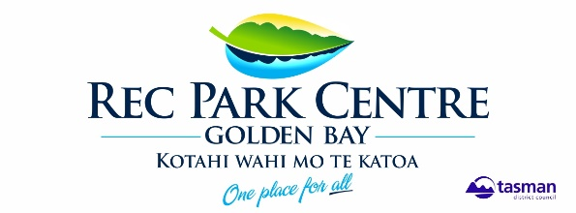

Tata Titanic Cardboard Boat Race

Saturday 25th January 2020, Tata Beach Boat Ramp.

9.00am: registration and judging

Race starts soon after judging

Enter on the Day

The Challenge

To Design and Build a Cardboard Vessel

(but not a submarine) and steer it around a marked course.

There will be plenty of help on hand to assist crews who have difficulty keeping their boat afloat.

For further information ph: Abbie Langford 027 624 0680 recreation@recparkcentre.co.nz

Cost of boat entry $10.00 – covers as many people as you like.

Conditions of Entry

The hull and structure of the boat must be entirely cardboard. Other materials may be used for decoration but cannot contribute to the floatation qualities of the vessel.

Tape, packing tape, string, staples, rope and paint can be used.

Wrapping the hull in cling film or plastic, tar substances, epoxy glue, fiberglass, resins, ‘two pot’ and varnish or any other protective substance is not acceptable.

Propulsion is by SINGLE PADDLES, oars, feet or sail or any combination. These can be commercial ones or homemade.

Any keel fitted must be made of cardboard.

A minimum of two crew must sit in or on the boat.

Boats must be easy to get in and out of (should evacuation be necessary)

Crew must be able to swim and must wear a properly fitting life jacket.

This is a family friendly event and we encourage creativity.

Entries deemed offensive will not be allowed to participate.

Teams have worked hard on their entries; therefore, all teams will show respect and allow the opposition to compete fairly, and vandalism of other craft is prohibited.

Prize Categories

Most Dramatic Sinking
First to Finish
Best Dressed Female
Best Dressed Male
Youngest Competitor
Oldest Competitor
Bribery and Flattery Award

Junior Prizes
Most Artistic Boat
Best Crew Appearance and Entertainment
Sea Worthiness

Senior Prizes
Most Artistic Boat
Best Crew Appearance Entertainment
Sea Worthiness

Plus spot prizes donated by local businesses

