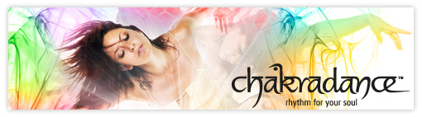

Awakening

My invitation is for you to find what thousands of others have found, the unravelling of blocked energy, a deepened connection to your true, authentic self, and the feeling of coming home.

Come and Join me for a powerful 9 week awakening journey with each 90 minute class focusing on a different chakra, includes an introductory and integration class.

Come and explore. Have fun. Find meaning. Let go. Look deeper into each chakra, each part of you.

Chakradance is a beautiful dance allowing you to blend free-flowing movements with chakra resonate music, guided imagery and mandala art.

Chakradance a healing dance/movement practice that will free the energy in your body and open you to a deeper experience of life.

Bookings essential, places are limited, email Sharon
sharonthomashealing@gmail.com

For more info: www.sharonthomas.co.nz

Course cost: $135 (Introductory special)

Next course dates: Sundays 7.00pm - 8.30pm
4th October - 29th November

Venue: Natural Living studio, Founders park, Nelson

