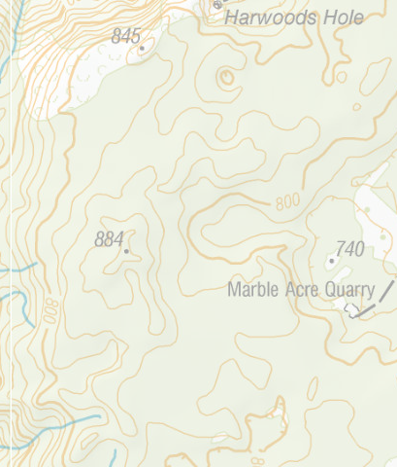
Canaan Rogaine

Sunday 25th August 2024

3 hr Fundraising Rogaine
11am start
Registration and map collection from 10am Harwood’s Hole car park.
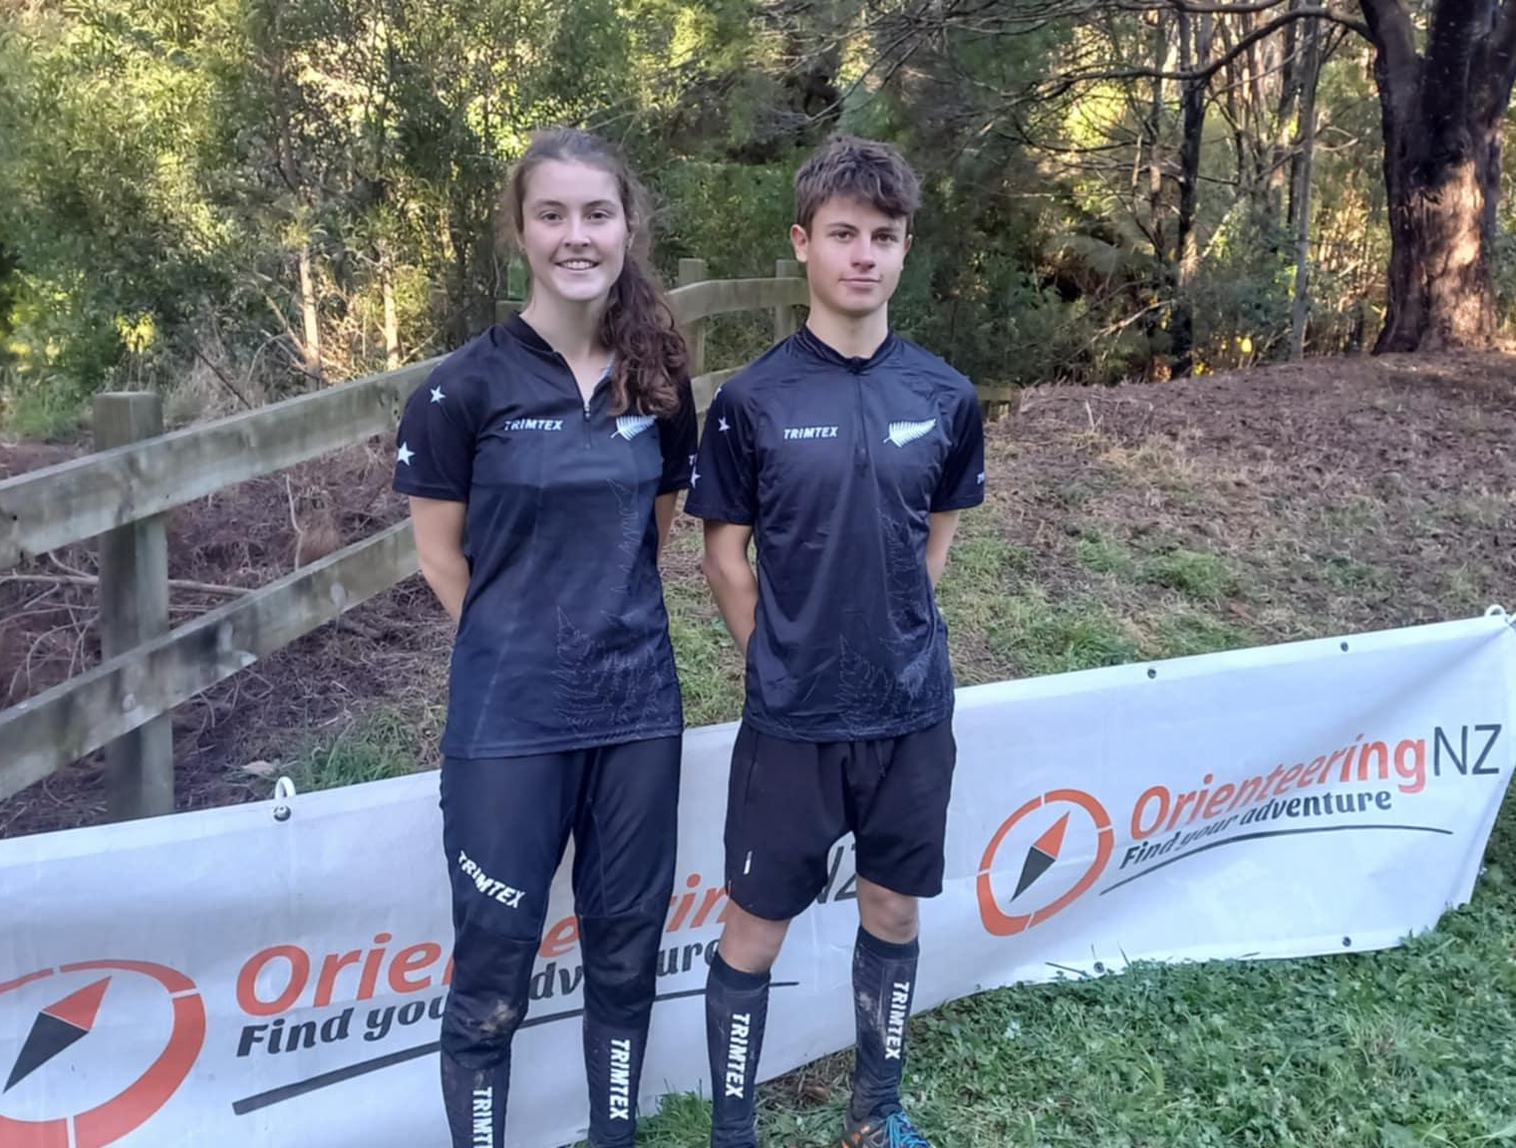
Entry
$30 Adult
$15 Student
$10 Under 13 (Adult supervision compulsory)
$50 Family
$60 Spring Challenge team

Entry via lilregie https://canaan-rogaine.lilregie.com/

Please bring all your safety gear:  whistle, warm hat, warm top, raincoat, compass and SI card if you have one.  BYO food and water |  | Thank you for supporting Lani and Micah, who are competing in Australia as part of the New Zealand Secondary School Orienteering Team in September.
Entries Close 22nd August 2024 at 10pm. (We need to know numbers to print maps).
Thanks for supporting Lani and Micah who are off to Auzzie with the NZ Secondary School team in September.
Enter here: https://canaan-rogaine.lilregie.com/
On the day
From 10am sign in and maps available (Harwoods Hole carpark)
10:45am briefing
11am event start
2pm event finish

Entry fees
$30 Adult
$15 Student
$10 Under 13 (Adult supervision compulsory)
$50 Family
$60 Spring Challenge team

FAQ
How does a Rogaine work?
You will be given a map with all of the controls on it. It’s up to you to make a route and navigate your way around parts (or all) of the map within 3hrs. Travel at your own pace (and navigational ability) to collect as many controls (points) as you can.

How fit do I need to be?
Go at your own pace. Often accurate walkers collect more points than some runners! Just make sure you’re back before the 3hr time limit is up.

How do the points work?
Each control (check point with a flag) is worth a designated amount of points, usually closer ones are worth less than ones on tops of hills or hidden in creek beds! If it is #34, it is worth 30 points, #72 is worth 70 points an so on.

What is an SI card/dibber?
You will be allocated an SI card, (or bring your own). This is a small electronic device that fits on your finger with elastic. It makes a beep when you insert it at a control. It keeps track of which controls you have visited and adds up all your points at the end. (They’re expensive so keep it on your finger, lost SI cards will be charged for).

How many can I have in a team?
As many as you like, (as long as you’re all paid up, it is a fundraiser after all). Keep in mind the larger the team, the harder it is to keep together!

How far apart can we be?
You must stay within 20m of each other at all times and be visible to each other.

Age limit
There is no age limit if children are accompanied by an adult. Due to the nature of the environment and hazards that exist, young children will need to be supervised at all times. A capable team of 13-year-olds can enter as a team.
What happens if I want to finish early?
Come on back when you’ve had enough of the wonderful outdoors and scenery at Canaan Downs. Important: Download your SI card so we know you’re back. Then sit back and admire all the places you’ve gone and the points you’ve collected.
What happens if I’m late back?
If you arrive back after the 3hrs you will lose points. For every minute (or part of) you are late back you will lose 30 points. eg 3hr and 5 seconds you will lose 30points. If you are more than 15 minutes late back you will lose all of your points.
Finishing and Safety
Once you have returned it is compulsory that you download and check in with the organisers, even if you’ve got zero or minus points! This ensures that we don't send an unnecessary search party out for you!

Route choice - Safety map
Before you head out you will be asked to mark your intended route on a copy of a map that the organisers will keep. It doesn’t mean you have to go that way, but if you don’t return on time it allows the organisers to have a rough idea where to start looking!

Will there be any food or drink to buy?
Not really, there’ll be some Sprite/Coke to purchase for $2 a can, but you’ll need to bring your own food and water for the event.

Can I camp at Harwoods hole carpark the night before?
You sure can, just pay a small fee at the DOC kiosk and settle in for a night in the hills. Toilets and running water supplied (but not treated). Why not head up the day before and explore the iconic Harwoods Hole and the lookout or take on the Rameka mountain bike track if you’ve got a taxi driver to collect you!
The Canaan Downs area is renowned for its stunning landscapes and tranquil atmosphere. With the right gear and route choice, and the knowledge that you don’t have to be on course for the whole 3-hours, we are confident the event will be a huge amount of fun.
Safety is paramount and participants need to be aware there are many natural hazards to be mindful of, these include, but are not limited to; loose rock, cliffs, steep ground, uneven ground, exposure to sun, wind and weather. Participants will spend most of their time walking on open farm land, retired farm land, forest and vehicle tracks.
For safety reasons there will be a minimum amount of gear and equipment that each person must carry or wear at all times. The event is in a forest/open farm land environment and weather can change rapidly in the hills and temperature can drop quickly.
Compulsory Clothing
Waterproof jacket
Fleece jersey
Thermal top and pants
Warm hat (BUFF, woolen hat, balaclava)
Gloves
Compulsory Equipment
Compass
Whistle
Backpack
Water bottle or bladder
Each team must carry a basic first aid kit that includes; bandage, wound dressing, pain relief, strapping tape and survival blanket.
Highlighter to mark your route.

Acceptance of your entry means that you have read and will adhere to this code of conduct throughout this Rogaine.
This Code of Conduct is motivated by the following two considerations:
- respect for the property and lifestyle of landowners
- safety of event participants, organizers and helpers, and others affected by the event, including assistance for injured people.
Land, Environment, Property and Stock
Rogaining is an environmentally and socially friendly activity and we expect all participants, including event organisers, to reinforce this ethic.
- Respect the right of landowners to operate their business and lifestyle in privacy and security.
- Leave gates as you found them.
- Do not crowd or otherwise disturb stock.
- Cross fences at gates or major posts, or go through the wires.
- Do not drop litter.
- Avoid houses and accessory buildings and/or machinery and stay out of out-of-bound areas.
- No dogs, guns, fires or smoking.
- Report any damage or disturbance you may have caused, or seen.
- Keep streams and water bodies clean
- Take due care to avoid spread of weeds, pest or diseases (e.g., Didymo)
- Note that access approval to land for an event is limited to the event duration. It does not extend to before or after the event.
- Event organisers will respect individual landowner attitudes to access to private land, and will strive to maintain good relationships with landowners at all times.
Safety and Injury
  - Distress call – six or more short whistle blasts at about 1 second intervals, repeated every 1 to 5 minutes, or in reply to a Search call.
  - Search call – one long whistle blast of several seconds.
  - If someone in your team is immobilised, identify your position and send someone to seek help. If possible, leave someone else with the injured person, along with all spare clothing. For urgent assistance, use your whistle to give the distress call.
  - Any team hearing the distress signal MUST offer all assistance required.
  - If someone in your team is injured, but can walk, use your common sense in getting them back to base.
Safety – legislative requirements

Under the Health and Safety at Work Act 2015 much private land (e.g., farm land) is designated ‘workplace.’ Landowners must inform recreational visitors of significant workplace hazards. To ensure this:
  - Event organisers will elicit advice from the landowner or manager on safety hazards, preferably at both the course planning stage and several days before the event.
  - Event organisers will inform all participants of any such hazards relevant to the event in written or verbal briefings.
  - Organisers, course planners and participants will take reasonable care that their actions (or lack of action) do not put themselves or others at risk. They will comply with reasonable safety advice or instruction given by the landowner (usually via the event organiser), as far as they’re able to.
NOTES TO THE CODE
Gates and Stock
If you open a gate, your team must close it or identify a person in a following team who will explicitly state that they will close it. If you corner stock, move no closer than 50 metres and find an alternative way around. This is particularly important when the easy way out for the stock is towards you on a track. Drop below the track and sidle around well clear of the stock. Stock in the wrong place at the wrong time of year can easily cost farmers tens of thousands of dollars, and cattle in particular are surprisingly easy to spook, and will readily demolish a good fence, injuring themselves badly on the way. If you cause any damage, it is vital that you report it to the organisers as soon as practicable, so that repairs can be started.
Safety
Understand the Distress call and the Search call. Serious injury is very rare, but needs urgent action. For the more common injuries where people can still limp, use your common sense. This usually means assisting them to a road and returning to the event center to gain assistance.

